**AV Design**

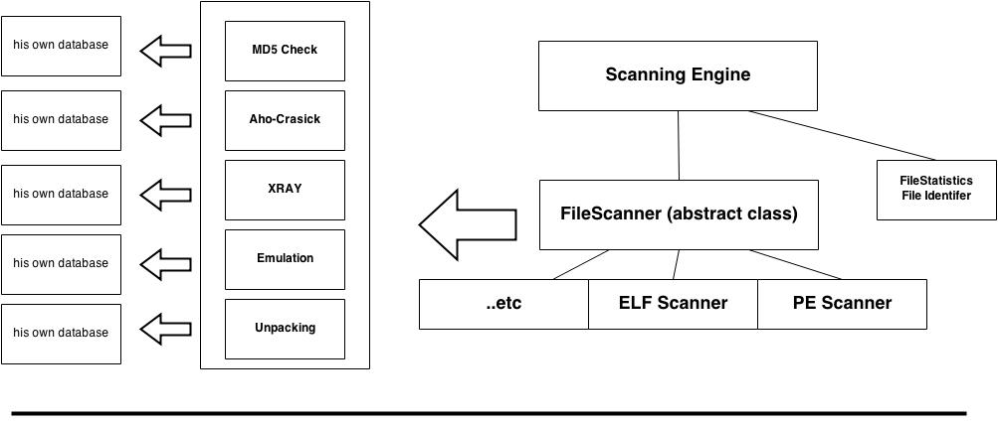

AV Structure

ScanningEngine.h

* Contains cScanningEngine class which is a one file scanning engine.
* Contains cScanningResult class that is used as a container of scanning results.
* Contains File Statistics / File Identifier (el 7eta de msh fahemha awe).

FileScanner.h

* Contains cFileScanner abstract class that works as an interface for different scanning techniques implemented as classes that inherit from this class.

Scanners Directory

* Contains dlls of the implemented scanning techniques. Each dll name is the technique name and also the class name. This class inherits from cFileScanner class.

AV Classes Structure

cScanningEngine class :

* This class is the core of the AV. In main we start by making object of this class and then calling the initialization function which prepare an array of the available scanning techniques (scanners) in Scanners Directory. After initializing the Scanners array we pass the engine one file and it start scanning this file through the Scanners array.
* Scan function is the one responsible for scanning files and it returns a cScanningResult object.
* Constructors :
  + cScanningEngine() : initialize required varriables and invoke init() [explained later]
  + cScanningEngine(char* filePath) : initialize required variables, invoke init() and scan() [explained later]
* Variables :
  + cFileScanner[] ScannersArray : Scanning techniques / scanners container
* Functions :
  + init() : initialize the scanning engine by loading scanners dlls from scanners directory to ScannersArray. Each object is casted as a cFileScanner since each one originally inherited the cFileScanner class.
  + scan(char* filePath) : scans a file through ScannersArray and returns a cScanningResult object that contains the result [explained later]

cScanningResult class :

* This class is considered as a container of the scanning process.
* It indicated the following :
  + Whether the scanned file is a virus or not.
  + Virus name / type of the detected virus.
  + Severity of detected virus [possible feature that comes with heuristics].
  + Array of the Detection methods that were used to detect the virus.
* Variables :
  + Virus : Boolean variables, true means virus and false means clean.
  + VirusName : string
  + DetectorsList : string array

cFileScanner